NBA Elo V1
Jacob Polomsky
June 19, 2024

I want to try a sport analysis. and figured this would be a fun project to solve. This is my first version of this type of analysis, where the goal is to predict winners of each game and roughly how much to bet on each game using Vegas odds. I do not expect this to beat Vegas, but to be a starting point which can be tuned later on. The reason for running an Elo model is like the Bradley–Terry Model, which I have seen in some books like Statistical Sports Models in Excel by Andrew Mack. I, but found that implementing different factors like home-field advantage to be difficult to implement in Python. The data is from Kaggle https://www.kaggle.com/datasets/cviaxmiwnptr/nba-betting-data-october-2007-to-june-2024. This data has all the winners from 2008 to 2025 and has one site betting odds from 2008 to 2023; the rest are missing. Some issues with this analysis that would need to be tuned later on 1. Issue is that I am only simulation the year 2021-2022 and every team starts off with the same Elo rating which is not accurate 2. is that home field advantage is a static value 3. issue is that we only have one value for odds which is not accurate as not all sites have the same odds 4.Ideally, I would want to have all of this data extracted from an API, as well as to automate historical data and all of the odds to be saved in another database for tuning later on.
I am going to skip the first three blocks, as they were there for later versions to deal with issue 4. The first thing is to pull in the Kaggle file and make sure it imported properly.
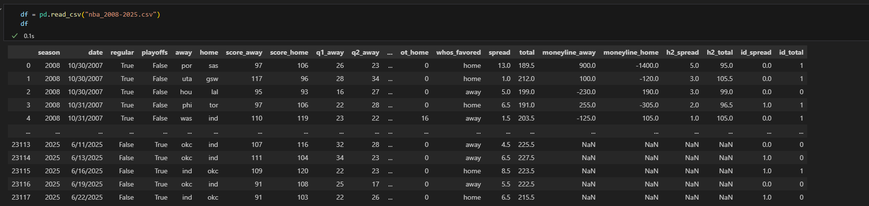
Next, I reviewed the data, including its type and description, to determine the necessary data cleaning steps. As for data cleaning. I only included data columns that are important to this analysis. I added a new row based on whether the home team won and the date from a string to a date time format. I made the abbreviation for the teams to be capital. I made the scores from floats to integers . Finally, I filtered to only included the 2021-2022 season as that is the final season that doesn’t have any missing files for the odds.
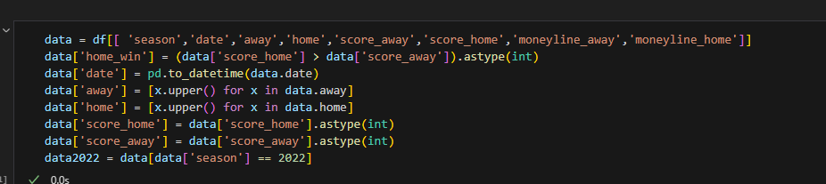
Here is what the new dataset looks like
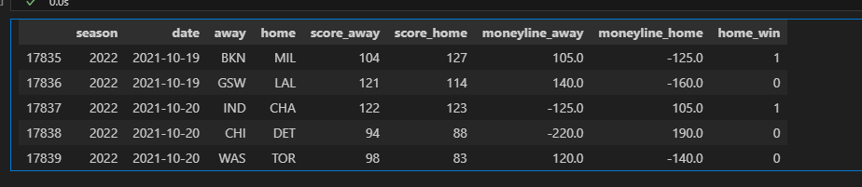
Next I made a static value to initiate Elo rating for all teams set to 1500. I also set home field advantage to 100 Elo points and K to be 20. This is based on https://fivethirtyeight.com/features/how-we-calculate-nba-elo-ratings/ which is recommended or the average in the article.
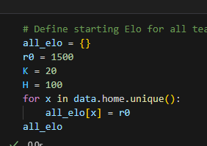
After giving each team an Elo rating, I made a function that gives the win probably based on those Elo ratings
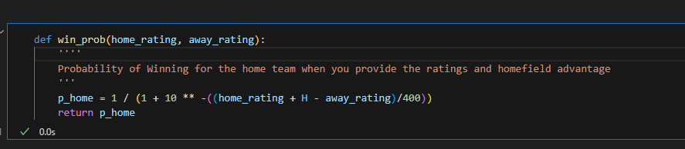
Then another function that updates the Elo function based on who won and lost
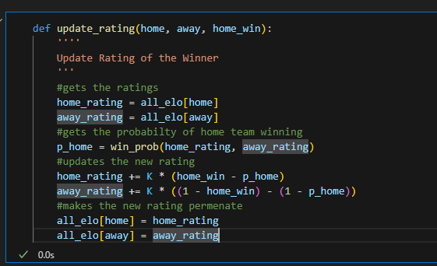
I got my made my predictions before updating the ratings for all games in the season as to not introduce bias or cheat.
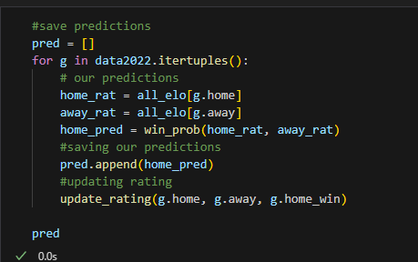.
I then added my probably for both the home team and away team over the course of a season.
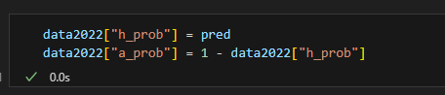
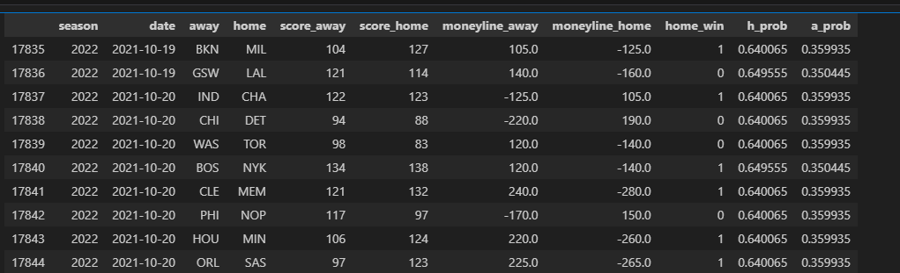
The Brier scoreis a good test to see how well our model pperforms Baseline shows the probability of just picking the home team which returns .247. We test that against my model which got .233 showing that our model slightly outperforms the baseline.
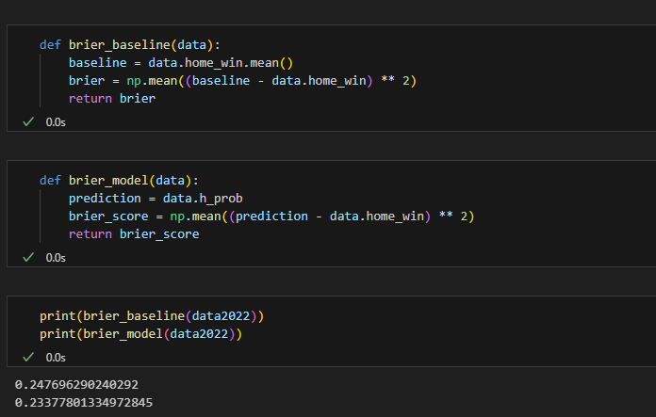.
Next what we need to do is to get the Vegas odds and to convert that to probabilities.
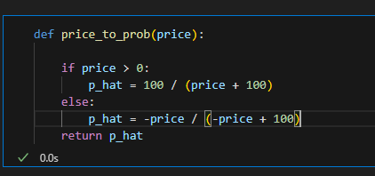
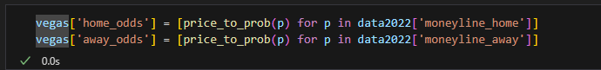
We apply another function to get the implied probabilites which converts the home and away probabilty to be 1.
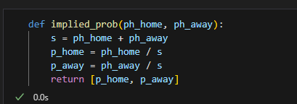
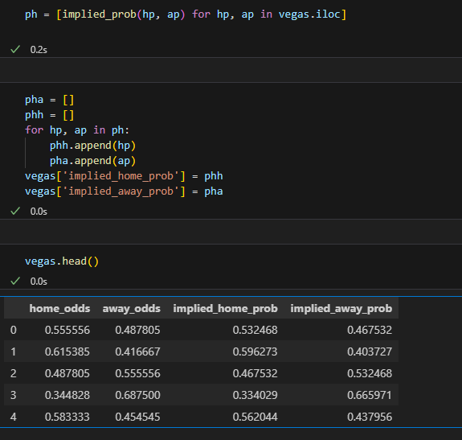
We add the implied probabilities back into our main dataset. This is not useful for our project now, but could be useful later.
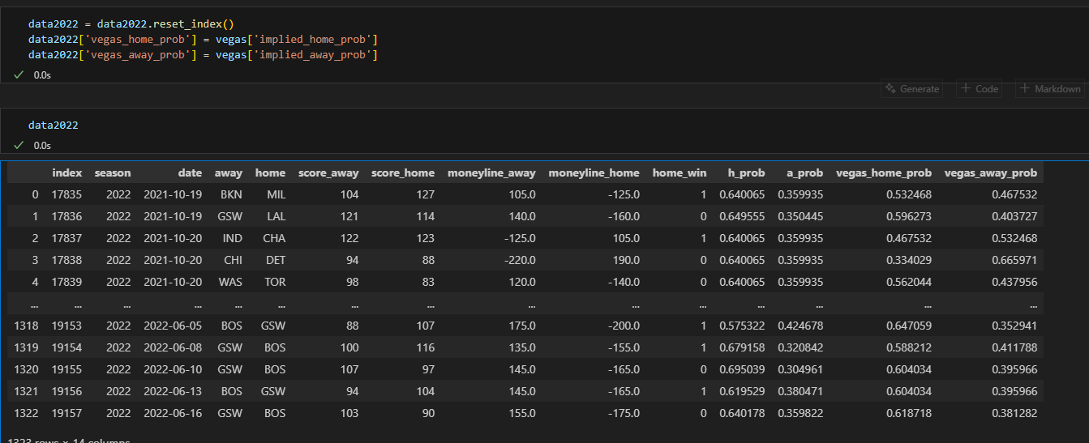
Now that we have both our probability and Vegas probability, we use the Kelly rating to determine how much we should bet based on rating, which factors both Vegas monelyline odds and our prediction odds. The American to decimal fraction converts the money line into a multiplier based on what Vegas is willing to pay out. The expected value uses our probability and the vegas multiplier to give you the value of our bet. The Kelly function gives you the percentage of total cash you place on a specific bet.
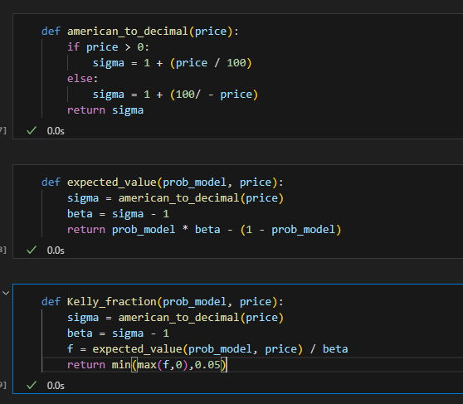
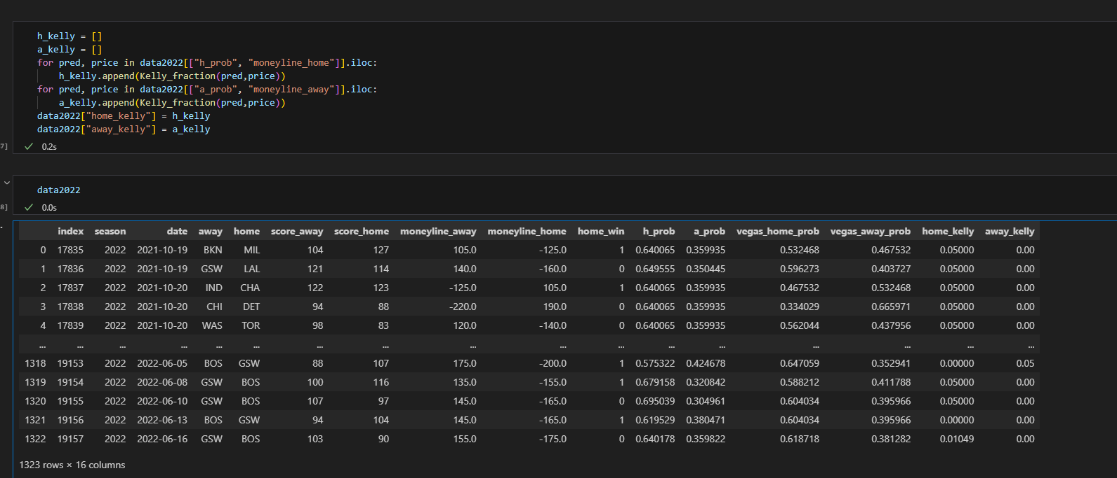
Now it is time for simulation. Let’s see how much money we would have won or lost over the course of a year. We are adding money based on Kelly rating to know what to wager to see how much we made each game.
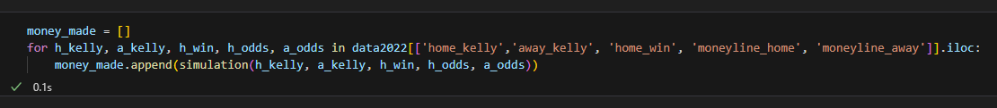
Over the course of the season. We would have made $3099, lost $3303 for a net rating of -$204.
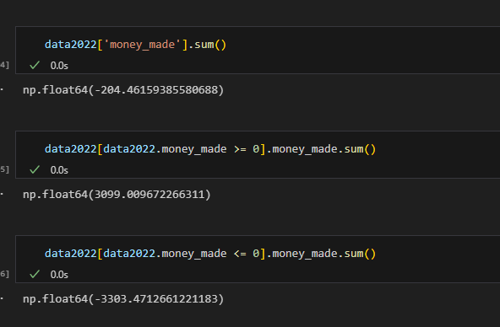
I ran this simulation another time and had a net rating of -125 with a Home field advantage of 60.
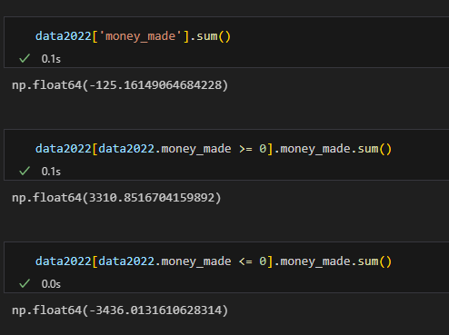
In conclusion, I found this to be a huge win. Not in the sense that this is ready to be used in the real world, but it is promising given the work that was put into it and how much more can be done. I expected it to be closer to -400 or -500. There is so much more that can be done that can minimize the losses. Like having a dynamic home field advantage that changes over the course of a season or, what might be better, having a home-field advantage depending on the team. Like in the game NCAA26, different teams can have bigger home-field advantages, making it harder for road teams to win. Also, I had all teams start off with the same Elo score, which can be changed to last year’s elo rating giving a slightly better starting elo score for simulation. There is also more that can be done like also factoring injuries, rest, travel that might affect the outcome of a game. Another thing is that there are more than just one gambling odds and being able to choose the odds that favor you can increase the cash multiplier giving you more bang for your buck.

